Welsh Shepherd’s Pie
Inspired by



DID YOU KNOW?
“FACT ABOUT DIJON MUSTARD!”

Ingredients
450g baby potatoes
2 cloves of garlic
1 tbsp butter
150ml cream**
1 tin of green lentils
150g mushrooms
5 sundried tomatoes
250ml tomato passata?
1 tbsp Dijon mustard
75ml vegetable stock
5 tbsp red wine
60g grated cheddar cheese

Nutrition – Total / Per Serving
Calories: ?kcal / ?kcal
Carbohydrates: ?g / ?g
Protein: ?g / ?g
Fat: ?g / ?g
Fibre: ?g / ?g
Sugar: ?g / ?g






Good for:

Star Rating:







Method
Step 1 - Preparation
Boil the kettle and preheat the oven to 220°C.
Chop the potatoes into small chunks.
Slice the garlic and mushrooms.
Drain and rinse the lentils.

Step 2 – Cook Your Potatoes & Make the Filling
Add the potatoes into a saucepan with the boiling water and cook until tender.
Meanwhile, heat some oil in a frying pan. Add the mushrooms and fry until brown (~5 minutes).
Add the soy sauce to the frying pan and mix for 1 minute before adding the garlic and sundried tomatoes.
Season with salt and pepper before adding the tomato passata, red wine, vegetable stock, and lentils.
Bring to a boil before reducing the heat to a simmer, Let simmer for ~9 minutes or until the mixture has thickened.


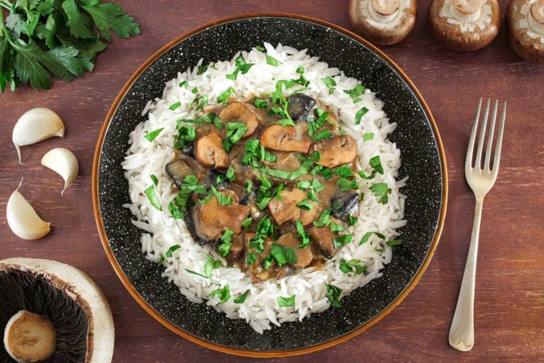
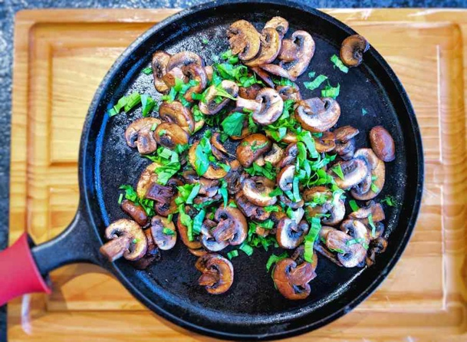
Step 4 – Ready, Set, Bake… and then Eat!
Place the final product into the oven and bake for ~15-18 minutes or until the top is golden brown.

Remove from the oven once ready and allow to sit for ~3 minutes before serving.

Enjoy!
Step 3 – Mash the Taters & Get Ready to Bake
Meanwhile, mix the cheddar cheese, mustard and cream in a bowl. Season with salt and pepper before setting aside.
Once the potatoes fall apart when you try to pierce them with a fork, drain them. Add the butter (AND???) to the potatoes and mash them until smooth. Add salt & pepper if desired.

Taste the filling and season with salt & pepper if required. Place the filling in an oven proof dish before adding a top layer of mash. Cover the mash with the cheese mixture.

